核定本：希望透過舉辦訓練班和現場調查的過程，能夠讓參與者隨著經驗的累積和從培訓課程學習相關知識與技術，增進其偵測、辨識繁殖鳥類的能力。如此，不僅能加強參與者的調查能力，也能讓調查資料符合科學分析需求。

* 同時針對不同身分或調查經驗的學員進行前後測測驗，比對培訓前後的成績差異，瞭解不同身份及調查經驗隊培訓課程的成效差異。
* 128人完整做完前後測，(林業署員工60人，志工68人)。
* 前後測結果分析方法採用廣義線性模型搭配常態分布(normal distribution)。
* 前後測、身分、調查為獨立變數，測驗總成績為應變數，志工姓名代碼為隨機變數。
* 身分：

1. 員工 (包含森林護管員、職員、技術士)、
2. 志工

* 調查：

1. 繁殖鳥與獼猴都調查 & 只有繁殖鳥、
2. 只有獼猴 & 未曾調查過

* 測驗題(10題方法、10題鳥種外型辨識、10題鳥音辨識、1題綜合鳥種外型辨識、1題低海拔森林鳥音辨識、1題中海拔森林鳥音辨識)
* 分析工具採用R語言4.2.1版(R core team 2020)套件 glmmTMB (Brooks et al. 2022)進行分析。

model_total <-

glmmTMB(總分 ~ Test + 身分 + 調查 + (1|姓名), data = DT.1, family = gaussian)

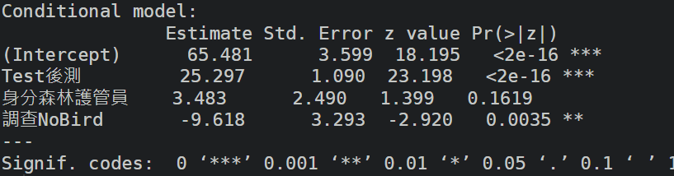

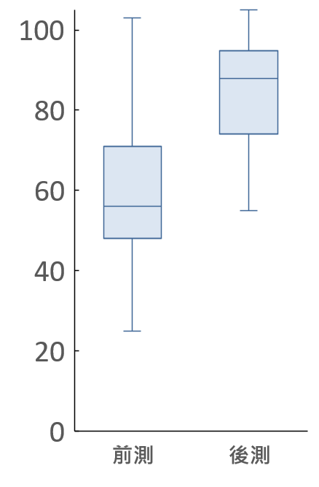

model_mothod <-

glmmTMB(score_方法 ~ Test + 身分 + 調查 + (1|姓名), data = DT.1, family = gaussian)

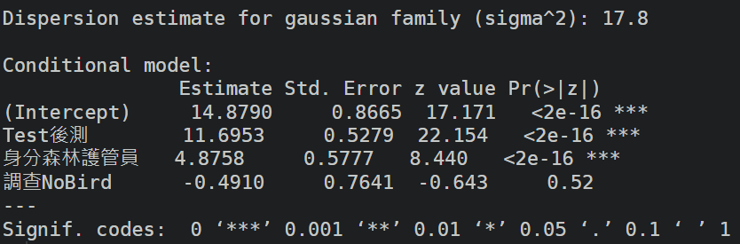

model_picture <-

glmmTMB(score_照片 ~ Test + 身分 + 調查 + (1|姓名), data = DT.1, family = gaussian)

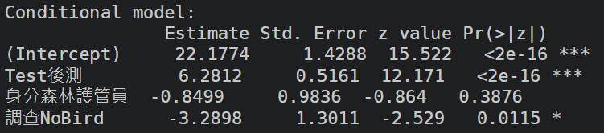

model_sound <-

glmmTMB(score_聲音 ~ Test + 身分 + 調查 + (1|姓名), data = DT.1, family = gaussian)

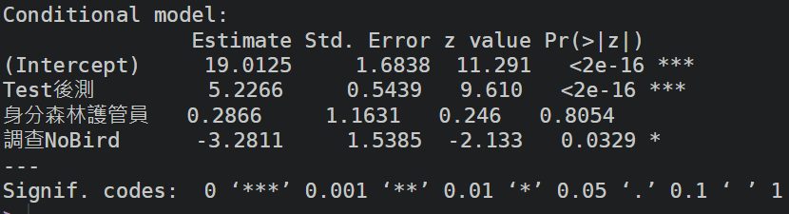

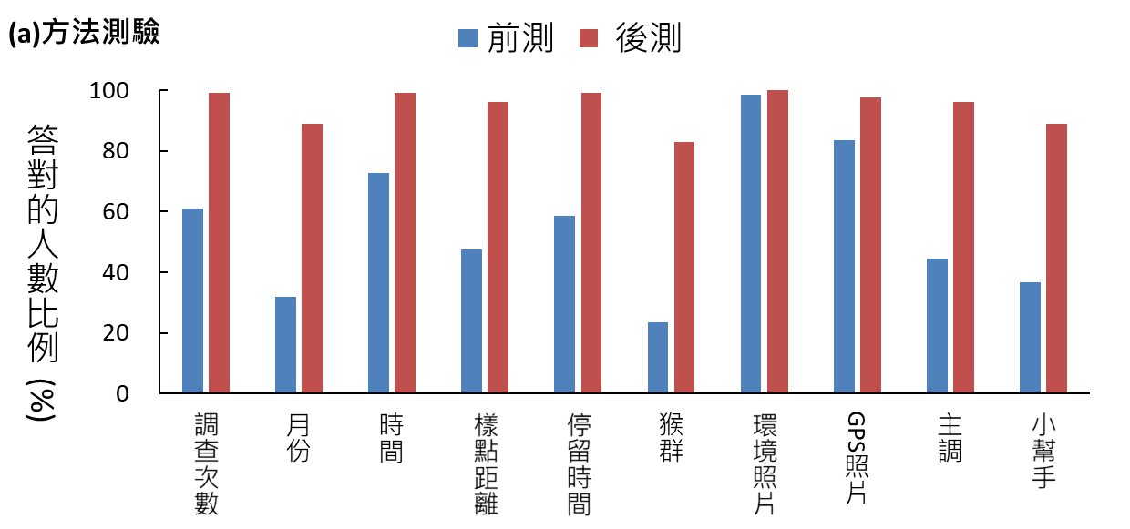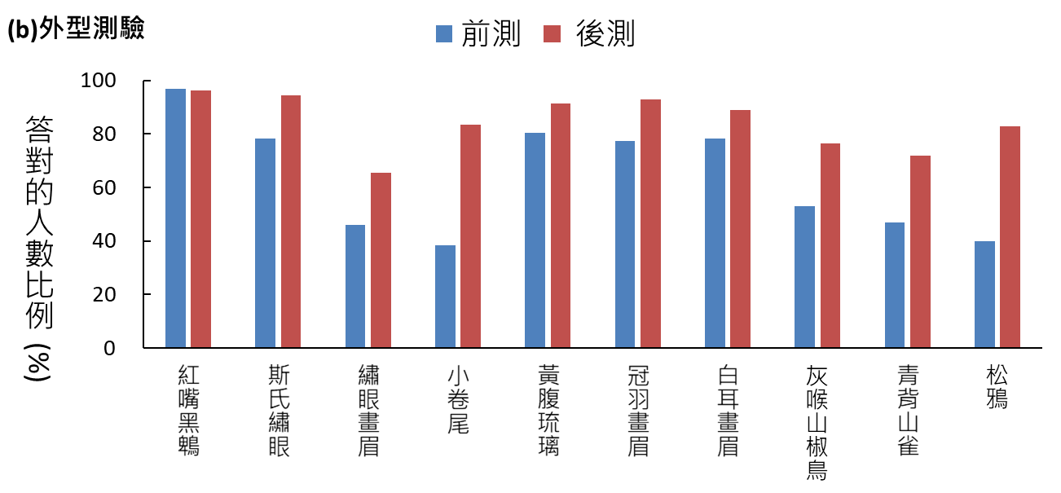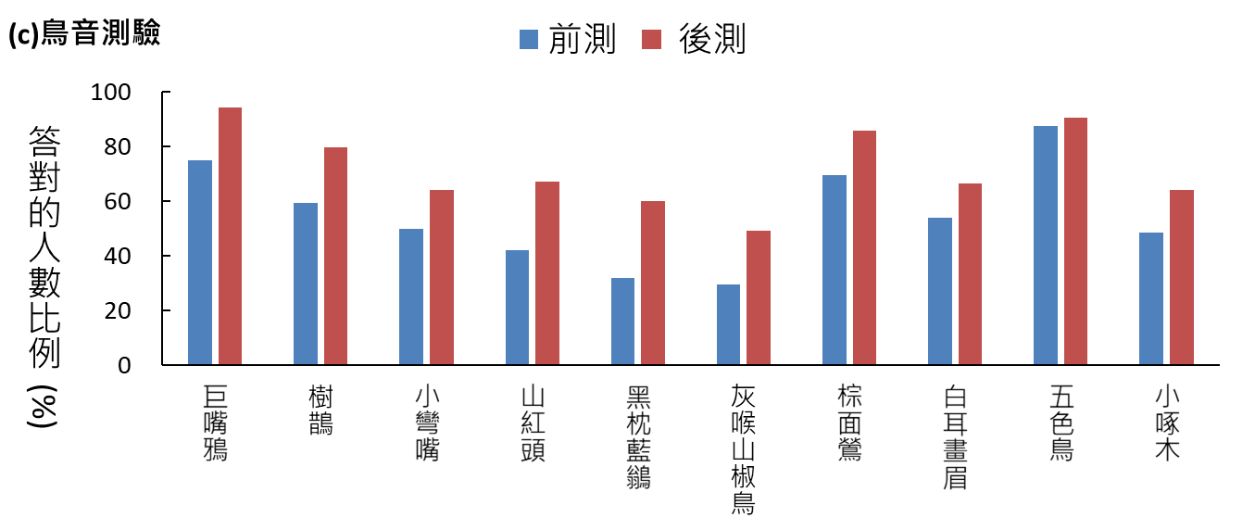

[[1]]

Paired t-test

data: 方法1 by Test

t = -8.8754, df = 127, p-value = 5.545e-15

alternative hypothesis: true mean difference is not equal to 0

95 percent confidence interval:

-0.468163 -0.297462

sample estimates:

mean difference

-0.3828125

[[2]]

Paired t-test

data: 方法2 by Test

t = -12.983, df = 127, p-value < 2.2e-16

alternative hypothesis: true mean difference is not equal to 0

95 percent confidence interval:

-0.657236 -0.483389

sample estimates:

mean difference

-0.5703125

[[3]]

Paired t-test

data: 方法3 by Test

t = -6.5215, df = 127, p-value = 1.494e-09

alternative hypothesis: true mean difference is not equal to 0

95 percent confidence interval:

-0.346224 -0.185026

sample estimates:

mean difference

-0.265625

[[4]]

Paired t-test

data: 方法4 by Test

t = -10.596, df = 127, p-value < 2.2e-16

alternative hypothesis: true mean difference is not equal to 0

95 percent confidence interval:

-0.5748314 -0.3939186

sample estimates:

mean difference

-0.484375

[[5]]

Paired t-test

data: 方法5 by Test

t = -9.0337, df = 127, p-value = 2.301e-15

alternative hypothesis: true mean difference is not equal to 0

95 percent confidence interval:

-0.4952382 -0.3172618

sample estimates:

mean difference

-0.40625

[[6]]

Paired t-test

data: 方法6 by Test

t = -13.203, df = 127, p-value < 2.2e-16

alternative hypothesis: true mean difference is not equal to 0

95 percent confidence interval:

-0.6827382 -0.5047618

sample estimates:

mean difference

-0.59375

[[7]]

Paired t-test

data: 方法7 by Test

t = -1.4198, df = 127, p-value = 0.1581

alternative hypothesis: true mean difference is not equal to 0

95 percent confidence interval:

-0.037401828 0.006151828

sample estimates:

mean difference

-0.015625

[[8]]

Paired t-test

data: 方法8 by Test

t = -4.2898, df = 127, p-value = 3.511e-05

alternative hypothesis: true mean difference is not equal to 0

95 percent confidence interval:

-0.20549296 -0.07575704

sample estimates:

mean difference

-0.140625

[[9]]

Paired t-test

data: 方法9 by Test

t = -11.28, df = 127, p-value < 2.2e-16

alternative hypothesis: true mean difference is not equal to 0

95 percent confidence interval:

-0.6060814 -0.4251686

sample estimates:

mean difference

-0.515625

[[10]]

Paired t-test

data: 方法10 by Test

t = -11.134, df = 127, p-value < 2.2e-16

alternative hypothesis: true mean difference is not equal to 0

95 percent confidence interval:

-0.6164682 -0.4304068

sample estimates:

mean difference

-0.5234375

[[1]]

Paired t-test

data: 照片1 by Test

t = 0.44581, df = 127, p-value = 0.6565

alternative hypothesis: true mean difference is not equal to 0

95 percent confidence interval:

-0.02686476 0.04248976

sample estimates:

mean difference

0.0078125

[[2]]

Paired t-test

data: 照片2 by Test

t = -4.31, df = 127, p-value = 3.243e-05

alternative hypothesis: true mean difference is not equal to 0

95 percent confidence interval:

-0.23938731 -0.08873769

sample estimates:

mean difference

-0.1640625

[[3]]

Paired t-test

data: 照片3 by Test

t = -4.0334, df = 127, p-value = 9.426e-05

alternative hypothesis: true mean difference is not equal to 0

95 percent confidence interval:

-0.29113329 -0.09949171

sample estimates:

mean difference

-0.1953125

[[4]]

Paired t-test

data: 照片4 by Test

t = -8.5443, df = 127, p-value = 3.449e-14

alternative hypothesis: true mean difference is not equal to 0

95 percent confidence interval:

-0.5580663 -0.3481837

sample estimates:

mean difference

-0.453125

[[5]]

Paired t-test

data: 照片5 by Test

t = -2.6136, df = 127, p-value = 0.01004

alternative hypothesis: true mean difference is not equal to 0

95 percent confidence interval:

-0.19218514 -0.02656486

sample estimates:

mean difference

-0.109375

[[6]]

Paired t-test

data: 照片6 by Test

t = -4.5855, df = 127, p-value = 1.07e-05

alternative hypothesis: true mean difference is not equal to 0

95 percent confidence interval:

-0.2236784 -0.0888216

sample estimates:

mean difference

-0.15625

[[7]]

Paired t-test

data: 照片7 by Test

t = -2.7106, df = 127, p-value = 0.007646

alternative hypothesis: true mean difference is not equal to 0

95 percent confidence interval:

-0.18922337 -0.02952663

sample estimates:

mean difference

-0.109375

[[8]]

Paired t-test

data: 照片8 by Test

t = -4.787, df = 127, p-value = 4.628e-06

alternative hypothesis: true mean difference is not equal to 0

95 percent confidence interval:

-0.3312602 -0.1374898

sample estimates:

mean difference

-0.234375

[[9]]

Paired t-test

data: 照片9 by Test

t = -5.4665, df = 127, p-value = 2.336e-07

alternative hypothesis: true mean difference is not equal to 0

95 percent confidence interval:

-0.340498 -0.159502

sample estimates:

mean difference

-0.25

[[10]]

Paired t-test

data: 照片10 by Test

t = -8.9622, df = 127, p-value = 3.425e-15

alternative hypothesis: true mean difference is not equal to 0

95 percent confidence interval:

-0.5245609 -0.3348141

sample estimates:

mean difference

-0.4296875

[[1]]

Paired t-test

data: 聲音1 by Test

t = -4.6962, df = 127, p-value = 6.77e-06

alternative hypothesis: true mean difference is not equal to 0

95 percent confidence interval:

-0.2776097 -0.1130153

sample estimates:

mean difference

-0.1953125

[[2]]

Paired t-test

data: 聲音2 by Test

t = -4.3953, df = 127, p-value = 2.312e-05

alternative hypothesis: true mean difference is not equal to 0

95 percent confidence interval:

-0.2945745 -0.1116755

sample estimates:

mean difference

-0.203125

[[3]]

Paired t-test

data: 聲音3 by Test

t = -2.5492, df = 127, p-value = 0.01199

alternative hypothesis: true mean difference is not equal to 0

95 percent confidence interval:

-0.24978532 -0.03146468

sample estimates:

mean difference

-0.140625

[[4]]

Paired t-test

data: 聲音4 by Test

t = -4.8053, df = 127, p-value = 4.283e-06

alternative hypothesis: true mean difference is not equal to 0

95 percent confidence interval:

-0.3529498 -0.1470502

sample estimates:

mean difference

-0.25

[[5]]

Paired t-test

data: 聲音5 by Test

t = -5.8267, df = 127, p-value = 4.384e-08

alternative hypothesis: true mean difference is not equal to 0

95 percent confidence interval:

-0.3767659 -0.1857341

sample estimates:

mean difference

-0.28125

[[6]]

Paired t-test

data: 聲音6 by Test

t = -3.3851, df = 127, p-value = 0.0009471

alternative hypothesis: true mean difference is not equal to 0

95 percent confidence interval:

-0.30948643 -0.08113857

sample estimates:

mean difference

-0.1953125

[[7]]

Paired t-test

data: 聲音7 by Test

t = -3.4134, df = 127, p-value = 0.0008615

alternative hypothesis: true mean difference is not equal to 0

95 percent confidence interval:

-0.25917365 -0.06895135

sample estimates:

mean difference

-0.1640625

[[8]]

Paired t-test

data: 聲音8 by Test

t = -2.7332, df = 127, p-value = 0.007167

alternative hypothesis: true mean difference is not equal to 0

95 percent confidence interval:

-0.21549796 -0.03450204

sample estimates:

mean difference

-0.125

[[9]]

Paired t-test

data: 聲音9 by Test

t = -1.2679, df = 127, p-value = 0.2071

alternative hypothesis: true mean difference is not equal to 0

95 percent confidence interval:

-0.0800217 0.0175217

sample estimates:

mean difference

-0.03125

[[10]]

Paired t-test

data: 聲音10 by Test

t = -2.9739, df = 127, p-value = 0.00352

alternative hypothesis: true mean difference is not equal to 0

95 percent confidence interval:

-0.26021845 -0.05228155

sample estimates:

mean difference

-0.15625

[[1]]

Paired t-test

data: 總分 by Test

t = -23.107, df = 127, p-value < 2.2e-16

alternative hypothesis: true mean difference is not equal to 0

95 percent confidence interval:

-27.46320 -23.13055

sample estimates:

mean difference

-25.29688